NAME: OGOLOGO MARK-SOLOMON CHUKWUBUZOR
MATRIC NO: 19/MHS11/101
COLLEGE: MEDICINE AND HEALTH SCIENCES
DEPARTMENT: PHARMACY
LEVEL: 100 LEVEL
COURSE: BIO 102
ASSIGNMENT
- Importance of Fungi to man
(i). Fungi are responsible for the mediation of decay of organic matter.
(ii). Microbes prevent the surface of the earth from being clogged-up with dead matter containing nutrients in them by returning them to various cycles.
(iii). Mushrooms, acts as source of food as they are eaten by human societies.
(iv). They produce important antibiotics e.g Penicillium notatum.
(v). Fungi (yeast) are important in food industry.
(vi). Many fungi species mediate the spoilage of wood, clothes, food, etc.
(vii). Some fungi act as important biological control agents as regards to some pests e.g houseflies, grasshoppers, etc.
(viii). It promotes the study of Medical and Veterinary mycology which deals with fungal skin diseases and infections in human beings and animals.
- Cell structure of a Unicellular Fungus
These organisms have the ability to function and exist due to presence of important cell materials. These cell materials such as; mitochondria, complex system of internal membranes, etc. considering Bakers’ yeast as a unicellular form of fungus. The cell structure is very simple, although it is one of the most advanced fungal forms due to its spore-producing structures. The cells exist in diploid or haploid states and they multiply rapidly through mitotic cell divisions. The divisions which include budding (nuclear division) and division of cytoplasm in a way that a segment of the cytoplasm is smaller than others.
Diploid cells arise from haploid cells by process of Plasmogamy and Karyogamy. A diploid cell may undergo meiosis under some conditions to produce 4 haploid spores-ascospores.
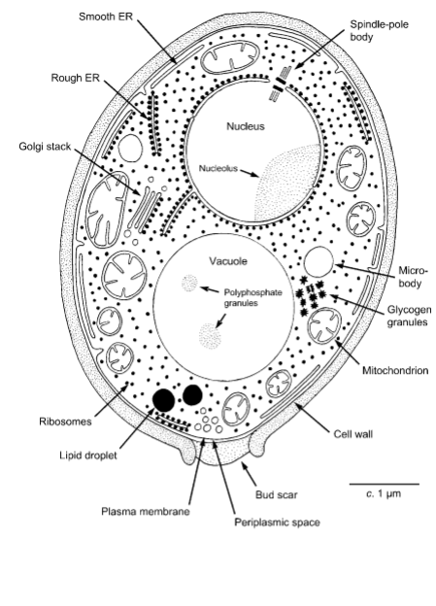
- Sexual reproduction in a typical Filamentous form of Fungi
Hyphae which is a filamentous form of fungi reproduces by releasing quantities of spores. It consists of three stages; Plasmogamy, Karyogamy and Meiosis. The processes are further outlined below:
(i). It occurs between two mating hyphae growing in the same medium.
(ii). Chemical interactions then occur between the two mating hyphae and induces growth perpendicular to the hyphae in opposite directions.
(iii). The growths get delimited by a wall which isolates many nuclei in what is called a Gametangium.
(iv). The two gamentagia fuse to form a zygote which may undergo dormancy or resting stage.
(v). The nuclei in the zygotes join in twos and independently undergo meiosis.
(vi). The zygote germinates under favourable conditions to produce a fruiting which liberates the haploid spores at maturity.
- Adaptation of Bryophytes to their environment
(i). They have definite structures which aid in absorption of water and nutrients from the soil. The plant body is further divided into two; an aerial portion and subterranean portion. The subterranean portion is the rhizoid but is not a true root as the case of advanced land plants.
(ii). The aerial portion is exposed to the atmosphere and undergoes some modifications that prevents excessive loss of water through the body surface(desiccation).
(iii). It also undergoes some other modifications which allows elimination of excess water from the plant body and aid in the exchange of gases between the internal parts of the plant and atmosphere. This results in openings on the aerial parts of the plant.
- (a) Eusteles
This is a type of vascular organization found in herbaceous dicotyledonous plants in which the vascular bundles are discrete, concentric collateral bundles of xylem and phloem.
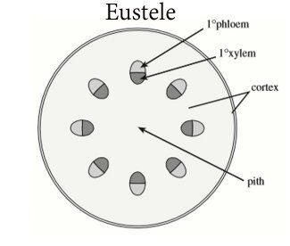
(b) Atactostele
It is a type of eustele found in grasses and many monocotyledonous plants, in which the vascular tissue in the stem exist as shattered bundles.
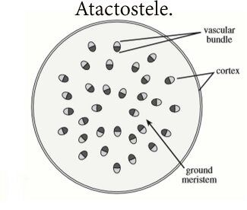
(c) Siphonostele
This occurs in more advanced vascular systems e.g stems of ferns and higher vascular plants. It is a stele in which the vascular tissue is in the form of a cylinder enclosing a parenchymatous pith.
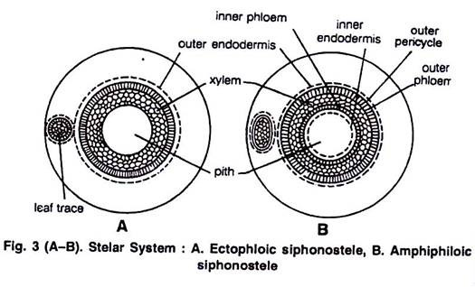
(d) Dictyostele
This is in a siphonostele where vascular supply to leaves is associated with leaf gaps and the conducting cylinder is a conducting one.
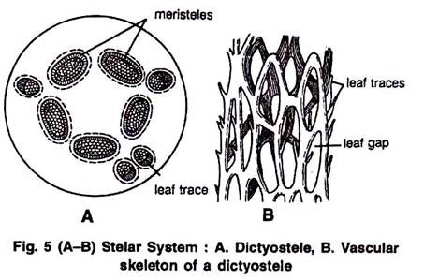
- Life cycle of a primitive vascular plant
Life cycle of a Fern
The life cycle has two different stages; (i). Sporophyte, which releases spores, and (ii) Gametophyte, which releases gametes. Gametophyte plants are haploid and sporophyte plants are diploid. This type of life cycle is called Alternation of generations.
The diagram below explains the life cycle;
